Assignment No. 9
Title: Creating an Application in SalesForce.com using Apex programming Language.

Problem Statement: Creating an Application in SalesForce.com using Apex programming Language.

Objective:
1. To student Apex Programming language
2. To create an application in SalesForce.com

Outcome:
Application in SalesForce.com using Apex programming Language.

Procedure:
Step 1: Signup or login
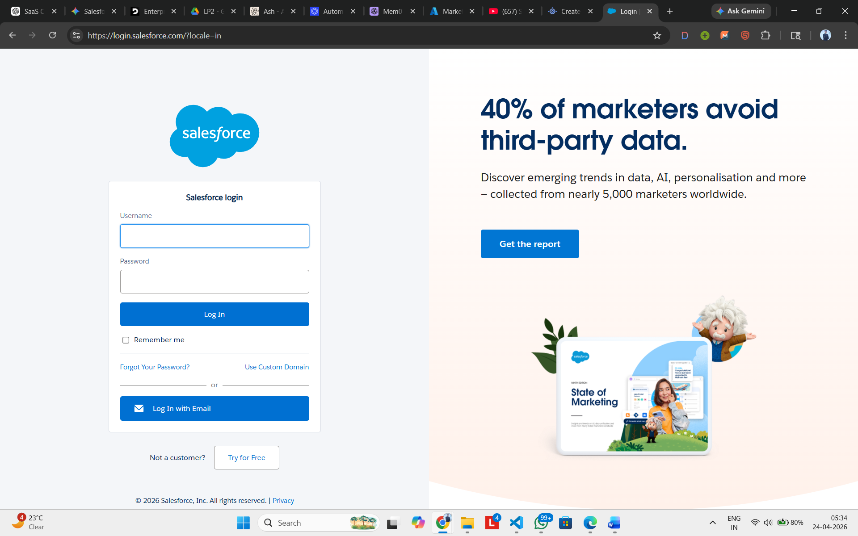
Step 2: After this you will reach the Dashboard
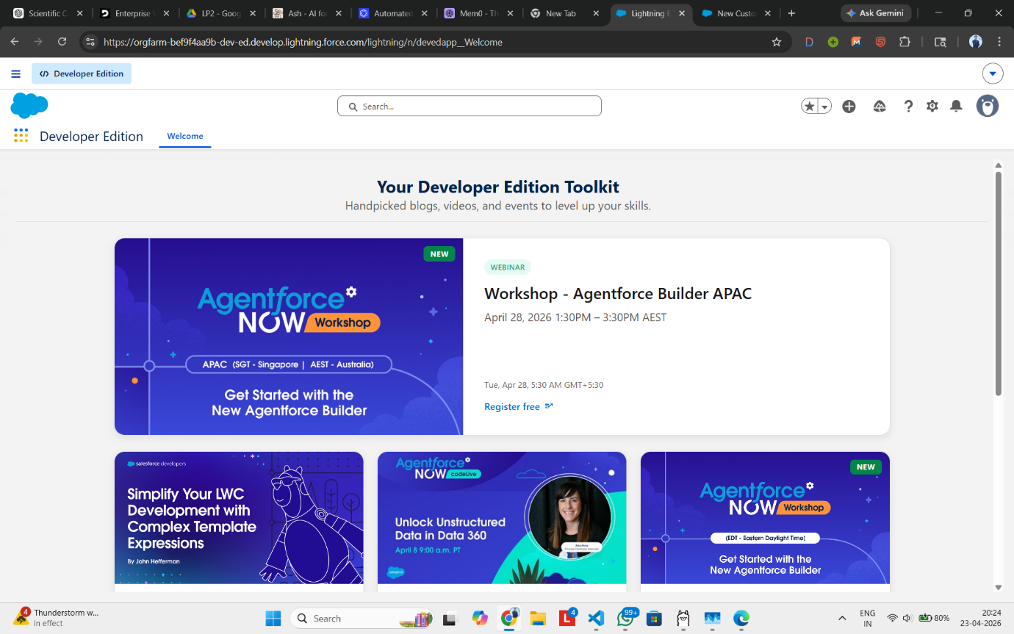

Step 3: Goto Seup>Developer Console. Create new Apex class
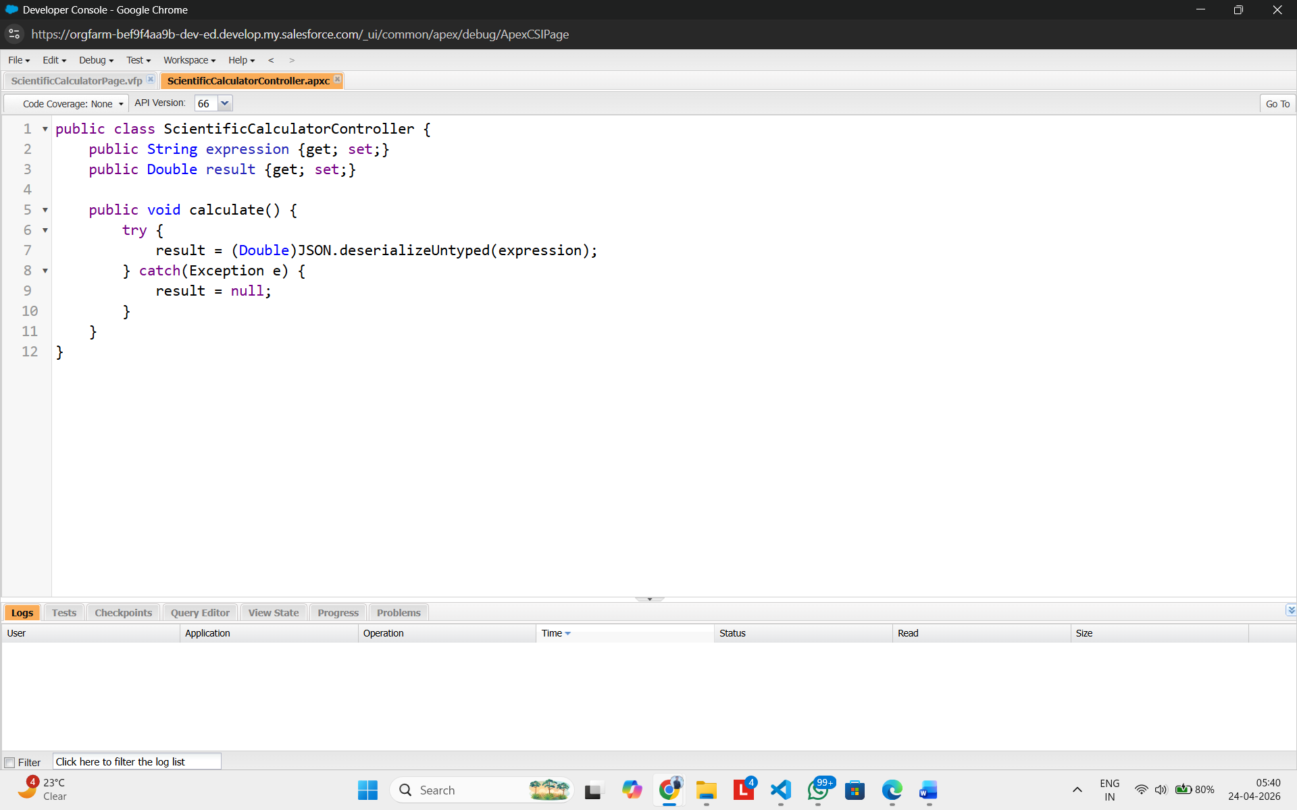

Step 4: Similarly, Create new VisualForce Page.
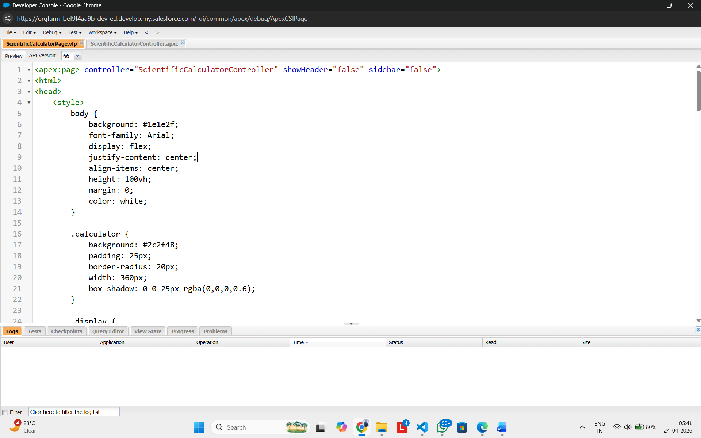

Step 5: Click preview on ScientificCalculatorPage.vfp and then a new tab will open with URL.
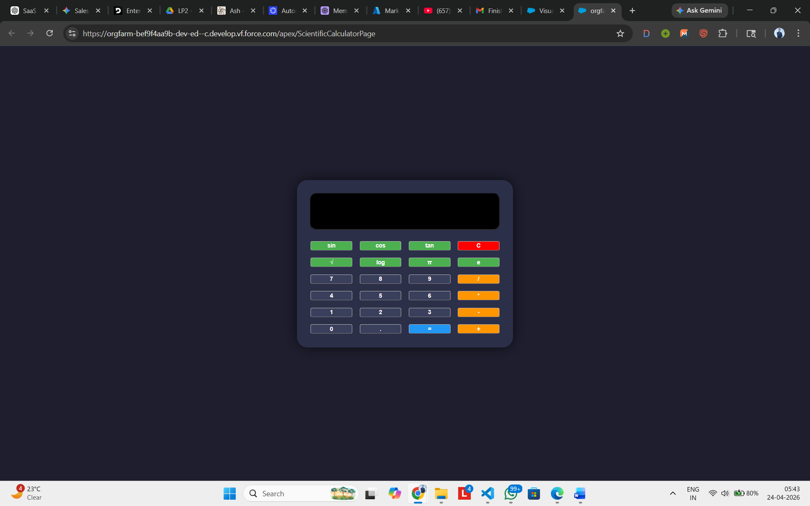

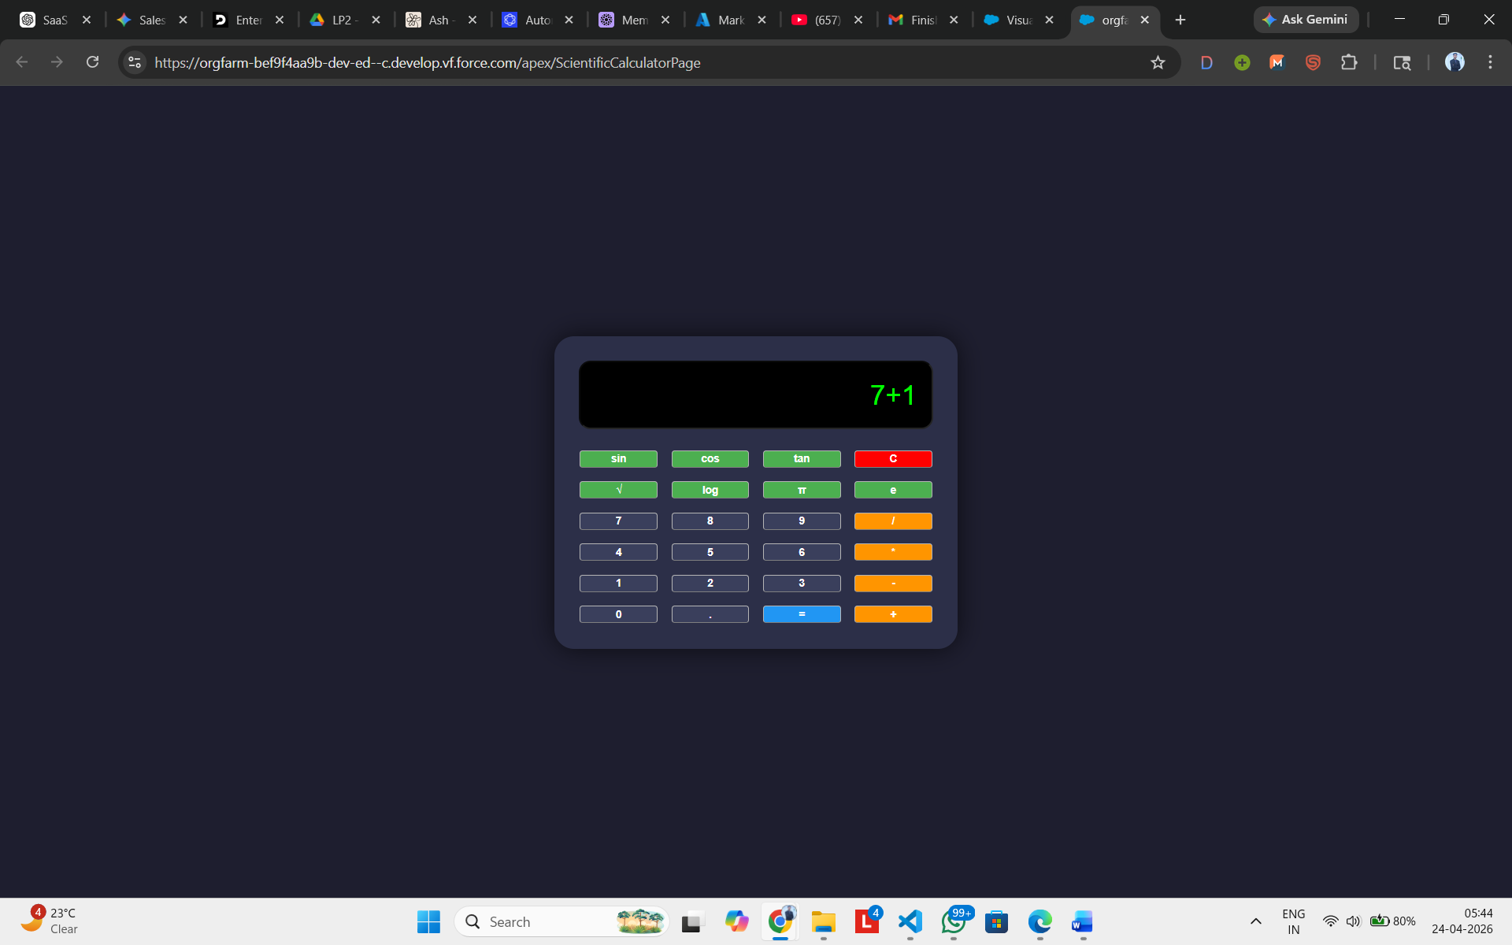

Conclusion: Hence, we have successfully created an application in SalesForce.com using Apex programming language.

